**Q1) Write a shell script to list all files in directory that have read, write, execute permissions**

**for file in \***

**do**

**if [ -f $file ]; then**

**r=0**

**w=0**

**x=0**

**if [ -r $file ]; then r=1**

**fi**

**if [ -w $file ]; then w=1**

**fi**

**if [ -x $file ]; then x=1**

**fi**

**if (( $r$w$x == 111 )) then**

**echo "$file has all the permissions"**

**fi**

**fi**

**done**

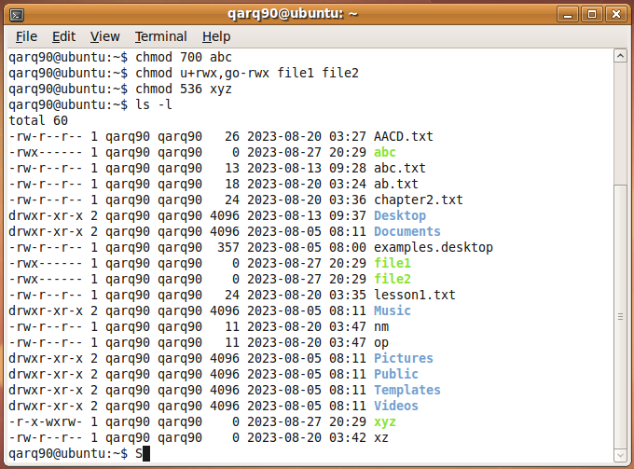

**Q2) Write a shell script to list all executable files in current directory**

**for file in \***

**do**

**if [ -x $file ]; then**

**echo "$file is an executable file"**

**fi**

**done**

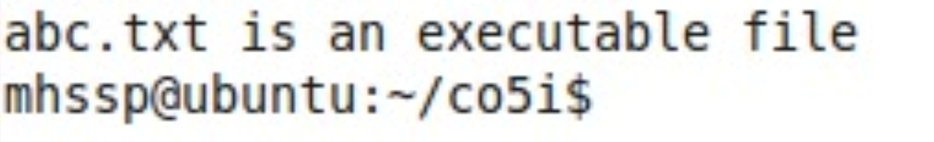

**Q3) Write a shell script to list all executable files in current directory**

**echo -n "Enter Filename: "**

**read file**

**if [ -f $file ]; then**

**chmod 777 $file**

**echo "$file has been assigned all the permissions"**

**else**

**echo "file does not exist"**

**fi**

